**SYNOPSIS ON**

**Himachal tourism**



**Institute of Engineering**

**Gumma,pragatinagar**

***Submitted by:-***

Vishal Chauhan

Ankush lagwal

Achintya Dwivedi

Pallavi

Vidisha

**(Diploma In COMPUTER Engineering)**

**6th SEM**

***Submitted To:-***

Mr.Nishant Sharma

Lecturer, Department of computer science

**CANDIDATE’S DECLARATION**

I hereby declare that the mini project work being presented in this report entitiled **HIMCHAL TOURISM ,**submitted in the department of computer science**, FACULTY OF TECHINOLOGY,**work carried out of by we under the guidance of Mr.Nishant Sharma Professor, department of computer science**,ABVGIET PRAGATINAGAR.**

**HIMACHAL TOURISM GOALS :-**

**GOAL 1:-**To establish himachal pradesh as a global brand and sub-brands in domestic and international markets.

**GOAL 2:-** To ensure substainable tourism which primarily benefits host communities and supports natural and cultural-heritage preservation.

**GOAL 3:-** To ensure visitos’s high quality experience and contribution to the safeguarding of the states destinations.

**GOAL 4:-** To create and enabling environment for investment and private sector development.

**GOAL 5:-** To build capacity and develop quality human resources in sustainable tourism ans state-of-the-art hospitality.

ACKNOWLEDGEMENT

**Keep away from people who try to be little your ambitions. Small people always do that, but the really great make you feel that you too, can become great.**

I take this opportunity to express my sincere thanks and deep gratitude to all those people who extended their wholehearted co-operation and have helped me in completing this project successfully.

First of all, I would like to thank **Mr. Nishant Sharma** for creating opportunities to undertake me in the esteemed organization

.

I also want to thank my teammates, friends and staff members of Poly department that have shared their needs and experiences with me.

My report will remain incomplete if I do not make a mention about my parents who expended all moral and financial support to me. I would like to special thanks to my parents.

**PURPOSE: -**

The purpose of this document is to give a detailed description of the requirements for the “**Himachal Tourism**” website. It will illustrate the purpose and complete declaration for the development of website.

**SCOPE:** -

Himachal Tourism is established by a dedicated team of faculty members and professionals who are committed to provide the best information related to our website like Study materials of courses such as php, java etc.

**Objectives:-**

The main Objective of this project is to provide better opportunities for people of all age groups.

**Privacy:-**

Privacy can be kept by secure login using password.

**Practicality:-**

The system is stable and can be operated with average intelligence.

**Efficiency: -**

There should be balance amongst various factors like accuracy, comprehensiveness on one hand and response timeliness of the system on the other hand.

**Cost:-**

It is desirable to aim for the system with a minimum cost subject to the condition that it must satisfy the entire requirement.

**Flexibility:-**

The system should be modifiable depending on the changing needs of the user. Such modifications should entail extensive reconstructing. It should also be portable to different computer systems.

**Security:-**

This is very important aspect requiring rigorous designing of database including hardware reliability, fallback proedures and physical security of data.

**LANGUAGE USED:**

**1 HTML:Sat**

**17**

**2012**

There are two parts in website one is design and other one is development. For developing good website you should do design of website very well. For design mostly designers use HTML language because it is the primary language and easy to use by designers.

HTML stands for Hyper Text Markup Language. It is simplest language which is created by human beings and it is used for creating static websites to provide information to humans.

**2) CSS:**

When you create a website for your business, time and money are likely to be major concerns. Luckily, there is a web design method that can help you save time and money while also improving your visitor's experience.

Cascading Style Sheets, more commonly known as CSS, has fast become the preferred web design method for the benefits it offers web designers and website visitors alike.

CSS is a language used to detail the presentation of a web page's markup language (most commonly HTML or XHTML) – such as colors, fonts, and layout. One of its key benefits is the way it allows the separation of document content (written in HTML or a similar markup language) from document presentation (written in CSS).

**3) PHP:**

PHP is a server-side scripting language. PHP (recursive acronym for PHP: Hypertext Preprocessor) is a widely-used open source general-purpose scripting language that is especially suited for web development and can be embedded into HTML.

The best things in using PHP are that it is extremely simple for a newcomer, but offers many advanced features for a professional programmer. Don't be afraid reading the long list of PHP's features. You can jump in, in a short time, and start writing simple scripts in a few hours.

There are three main areas where PHP scripts are used:

* Server- side scripting.
* Command line scripting.
* Writing desktop applications.

**INTRODUCTION TO MYSQL SERVER**

The MySQL server provides a database management system with querying and connectivity capabilities, as well as the ability to have excellent data structure and integration with many different platforms. It can handle large databases reliably and quickly in high-demanding production environments. The MySQL server also provides rich function such as its connectivity, speed, and security that make it suitable for accessing databases.

SQL stands for “Structured Query Language” and can be pronounced as “SQL” or “sequel – (Structured English Query Language)”. It is a query language used for accessing and modifying information in the database. IBM first developed SQL in 1970s. Also it is an ANSI/ISO standard. It has become a Standard Universal Language used by most of the relational database management systems (RDBMS). Some of the RDBMS systems are: Oracle, Microsoft SQL

server, Sybase etc. Most of these have provided their own implementation thus enhancing it's feature and making it a powerful tool.

Few functions of SQL are:

* store data
* modify data
* retrieve data
* modify data
* delete data
* create tables and other database objects
* delete data

**Xampp**

1. XAMPPs are packages of independently-created programs installed on computers that use a [Microsoft Windows](http://en.wikipedia.org/wiki/Microsoft_Windows) operating system.
2. XAMPP is an acronym formed from the initials of the operating system Microsoft Windows and the principal components of the package: [Apache](http://en.wikipedia.org/wiki/Apache_HTTP_Server), [MySQL](http://en.wikipedia.org/wiki/MySQL) and one of [PHP](http://en.wikipedia.org/wiki/PHP), [Perl](http://en.wikipedia.org/wiki/Perl) or [Python](http://en.wikipedia.org/wiki/Python_%28programming_language%29). Apache is a [web server](http://en.wikipedia.org/wiki/Web_server). MySQL is an open-source database. PHP is a scripting language that can manipulate information held in a database and generate web pages dynamically each time content is requested by a browser. Other programs may also be included in a package, such as [phpMyAdmin](http://en.wikipedia.org/wiki/PhpMyAdmin) which provides a graphical user interface for the MySQL database manager, or the alternative scripting languages Python or Perl. Equivalent packages are [MAMP](http://en.wikipedia.org/wiki/MAMP) (for the [Apple Mac](http://en.wikipedia.org/wiki/Mac_OS)) and [LAMP](http://en.wikipedia.org/wiki/LAMP_%28software_bundle%29) (for the [Linux](http://en.wikipedia.org/wiki/Linux) operating system).

**ER-DIAGRAM:-**

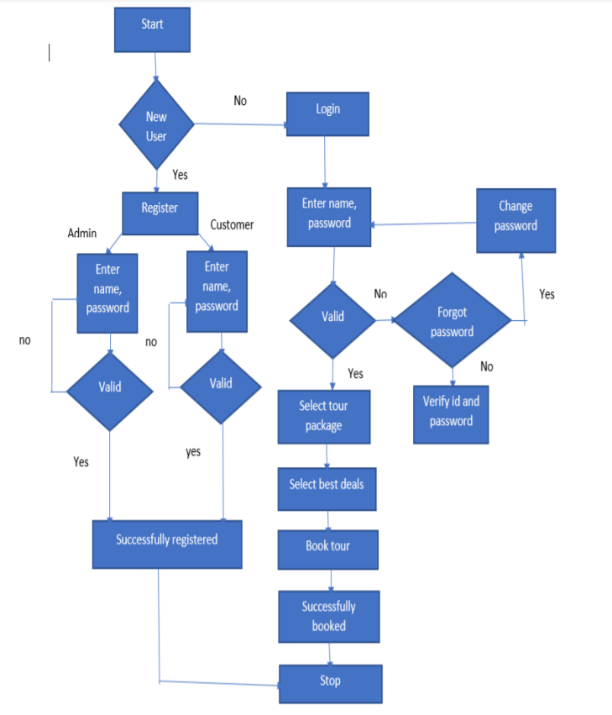

**DATABASE DIAGRAM:-**

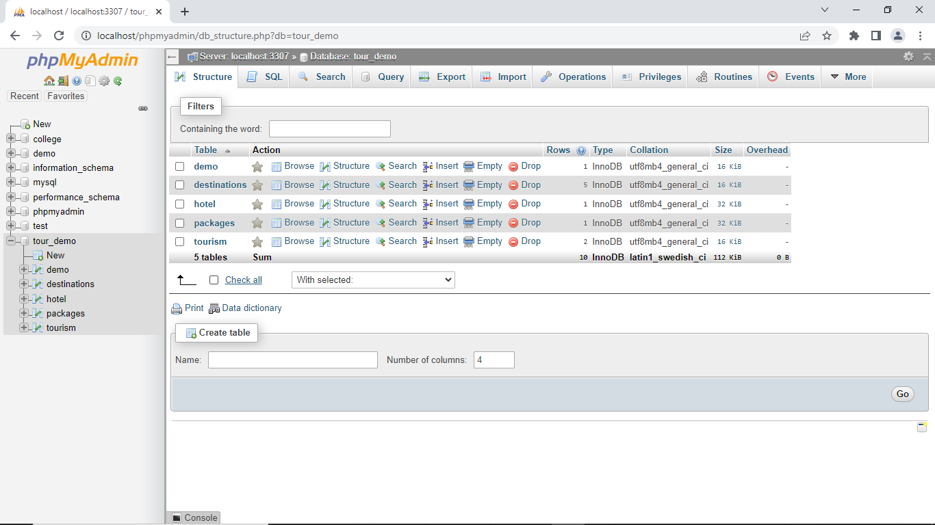

**BIBLIOGRAPHY:-**

1) [www.google.com](http://www.google.com)

2) [www.wikipedia.org](http://www.wikipedia.org)

3)[www.w3school.com/](http://www.w3school.com/)

4)[www.devguru.com/](http://www.devguru.com/)

5)[www.w3.org/](http://www.w3.org/)